**Snapshots of Excel/ Python**

**Problem 1 (d) –** *Snapshot Only, see Answers Sheet for Comparisons*

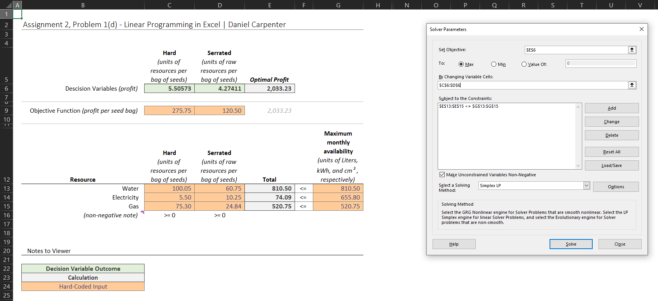

**Problem 1 (e) –** *Snapshot Only, see Answers Sheet for Comparisons*

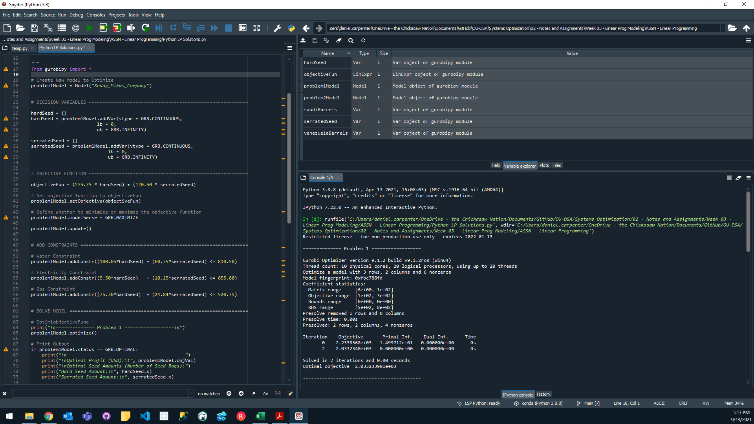

**Problem 2 (i) –** *Snapshot Only, see Answers Sheet for Comparisons*

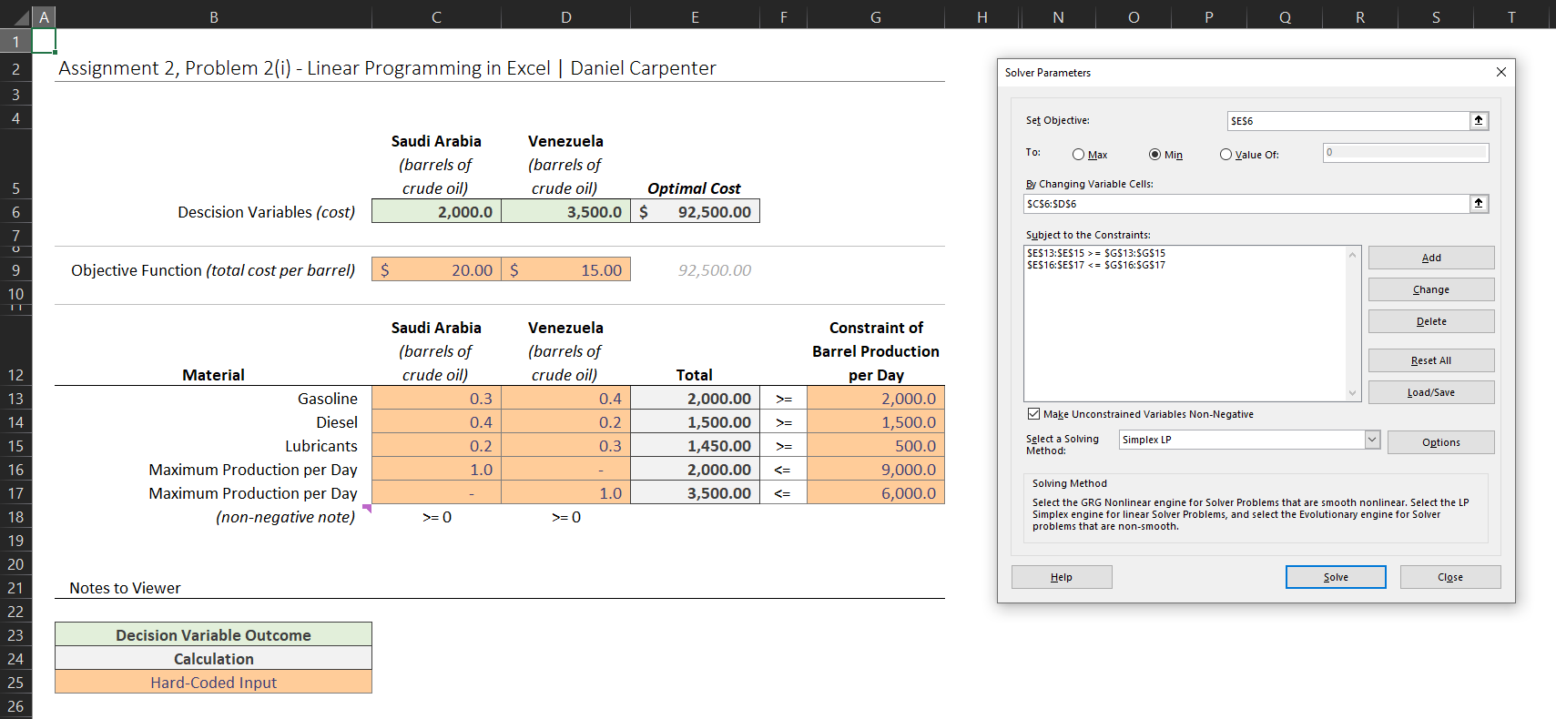

**Problem 2 (j) –** *Snapshot Only, see Answers Sheet for Comparisons*

